**/preview/**

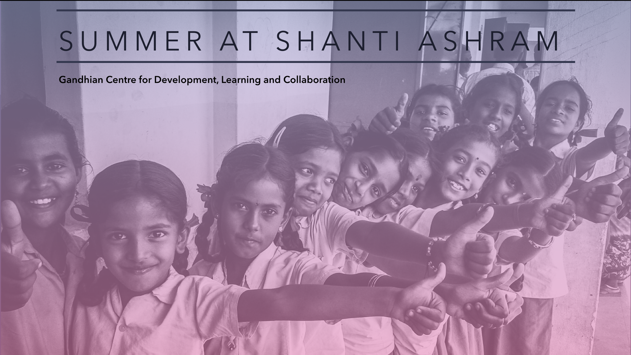

**Participatory Rural Appraisal**

PRA approach aims to incorporate the knowledge and opinions of rural people in the

planning and management of development projects and programmes. In 2 villages near Coimbatore PRA was conducted to determine the amenities that the required and their location.

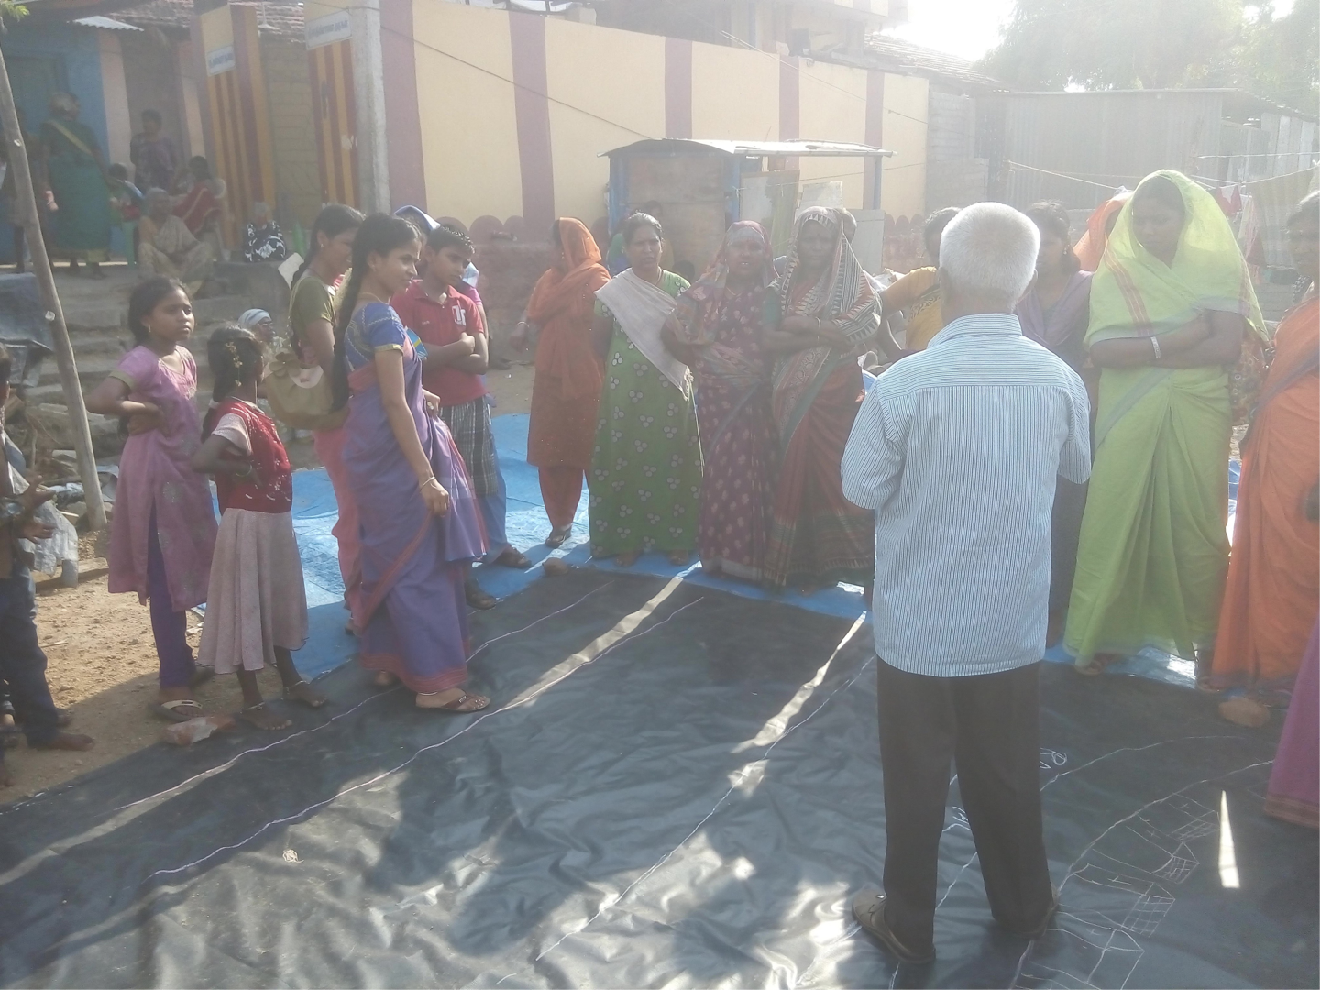

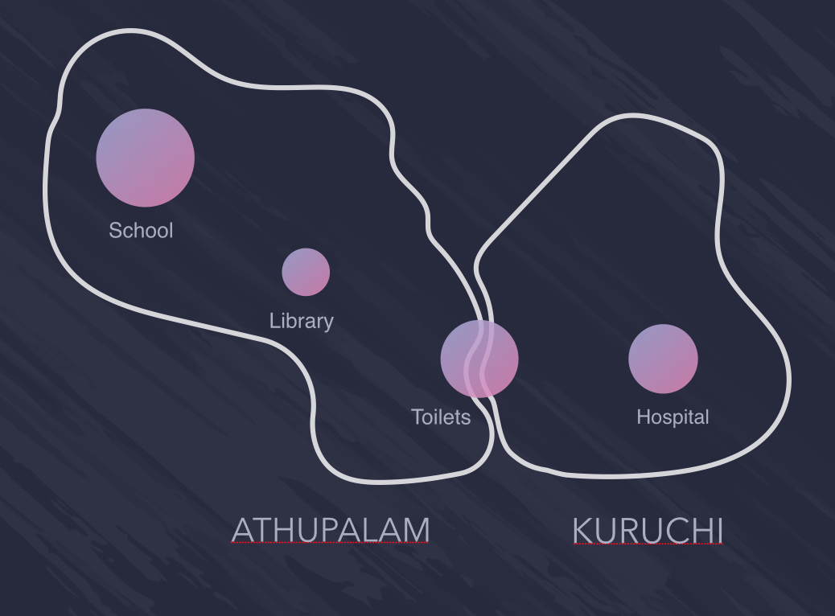

**Toilets location determined by PRA to be between**

**Both the villages**

**Scholarship Brochure Design**

The brochure was designed based on content covering the 15 years of consistent scholarship programme and the various schemes introduced during the period by the Ashram.



**Brochure Cover Page**

**User Studies**

The sample consists of 30 youths, between the age group of 18 - 22 hailing from rural, urban and peri-urban (Rurban)

**Goal**

To find out the density of penetration of smartphones amongst young adults. This is expected to fetch us patterns about what they use phones for - calling, messaging, education, business, entertainment, calculations and mainly medical purposes.

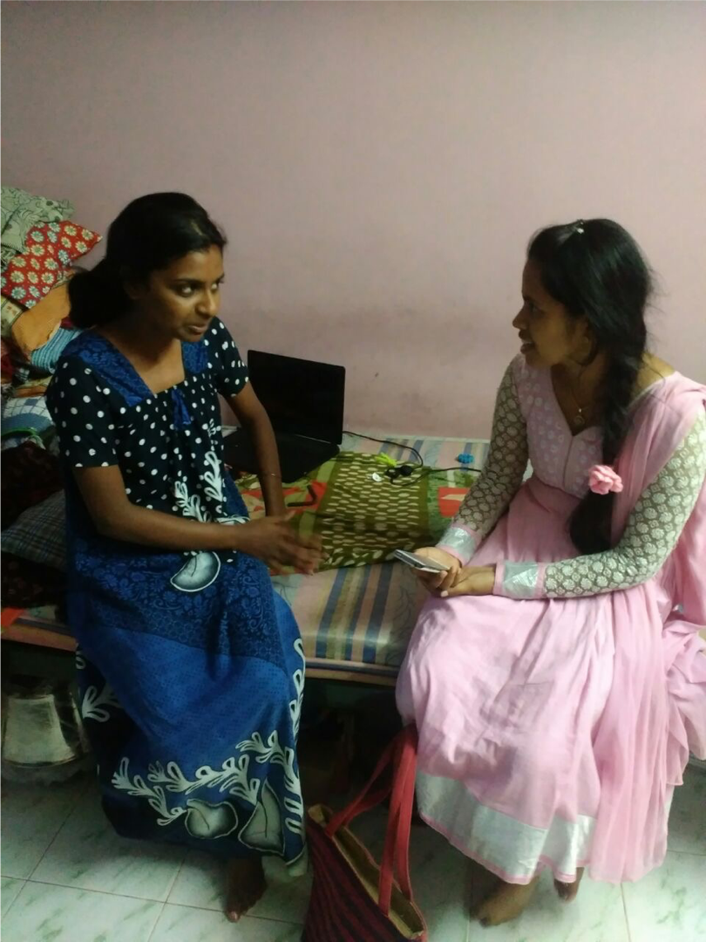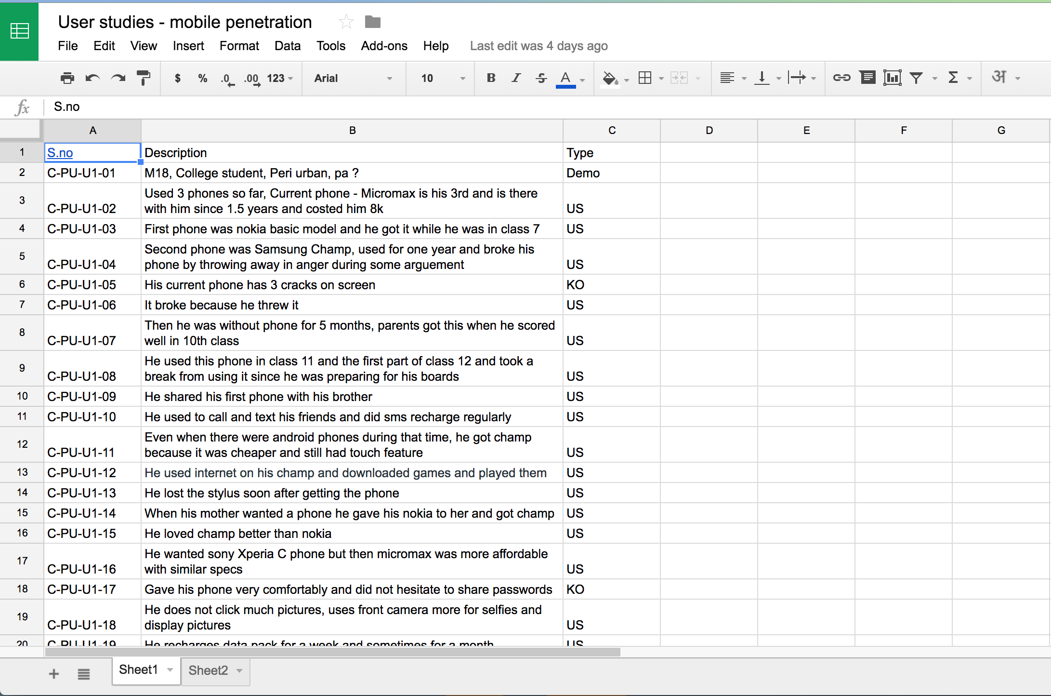

**Key Findings**

A user has a method to use the micromax phone despite the phone being broken and having touchpad problems

Friends discuss about apps, "new app irunda send pannuda"

A user downloaded hammer VPN - an app that can track wifi and passwords and help one use neighbour's wifi stealthily

A lot of touch screens are broken and cannot be repaired. The new phones are becoming use and throw while old basic model handsets are still in working condition after years

A lot of people working, spend time after dinner till they sleep on phones and internet

Find the Report [here](https://drive.google.com/drive/folders/0B372owFok6P-dlFqWTVIOXFWcVE)